March 27, 2023

Dear Parent or Guardian,

This year Salado High School will be offering Summer School for REMEDIATION. Remediation is for students needing to recover credit. Without earning the required credits each year, your child can be in jeopardy of not graduating with their class. Summer School is an opportunity for students to make-up courses by semester or by year. If students have failed a semester course or the entire year of a course (and did not average with a grade of 70), then they are eligible to attend. Our sessions will be offered IN PERSON ONLY, and the cost is $100 per session. The session will be three weeks, Monday through Thursday from 8:30am – 12:00pm. Students are expected to attend all three weeks to complete their course (s). Courses will be in an online platform so students can have continued access from home during the three weeks. Transportation will be the responsibility of the parent or student.

Remediation Summer School will begin on Monday, June 5th, and end on Thursday, June 22nd. The exact dates/times are listed below.

Remediation (Credit Recovery): Monday, June 5th - Registration: 8:00am-8:30am
Monday – Thursday: June 5,6,7,8: 8:30am-12:00pm
Monday – Thursday: June 12,13,14,15: 8:30am-12:00pm
Monday – Thursday: June 19,20,21,22: 8:30am-12:00pm

Seating is limited for remediation/credit recovery, so please RSVP to Rachel Lee at rachel.lee@saladoisd.org as soon as possible to reserve a seat for Summer School. Please call if you have any questions at the number below.

Thank you,
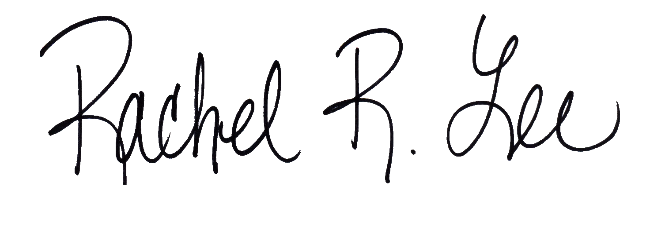
Rachel Lee
Assistant Principal
Salado High School
254.947.6989

